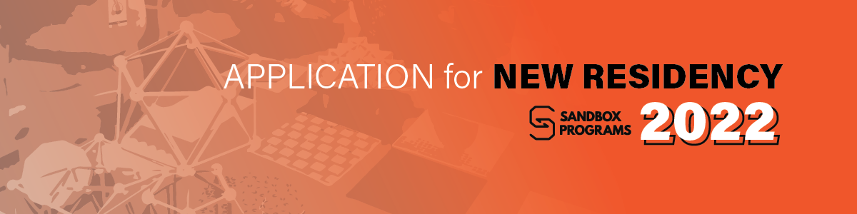

Areté Sandbox Residency - Application Form
For January-December 2022 cycle

Type of Grant
(Please tick which type of grant you are applying for)
◻︎ Sandbox Residence Grant Application |  | ◻︎ Sustainability Sandbox Grant Application

Working Title of the Proposed Project

Project Proponents and Affiliations
- Lead Proponent must be a full-time faculty member of Ateneo de Manila University
- CV’s of proponents should be attached to this application form
Lead Proponent (and affiliations)
Team Members (and affiliations)

Project Description
(Please keep to within 500 words)

What benefits would the Sandbox Residency bring to the project?
(Please keep to within 3-5 sentences)

Describe the project’s potential for experimentation and play to arrive at innovative and creative solutions?
(Please keep to within 3-5 sentences)

Describe the project’s potential for interdisciplinarity?
(Please keep to within 3-5 sentences)

Describe the project's potential to merge the sciences and the arts?
(Please keep to within 3-5 sentences)

For Sustainability Sandbox application:
Describe how the project connects to the the theme Life In Plastic Not Fantastic
(Please keep to within 3-5 sentences)

Other sources of funding that accompany this project.
◻︎ YES ◻︎ NO
If yes, please indicate the funding bodies and the amount of funding applied for or received.

Relevant information that you wish to share in consideration of your application?

Names and Signatures of Applicants:
Date of Application:

