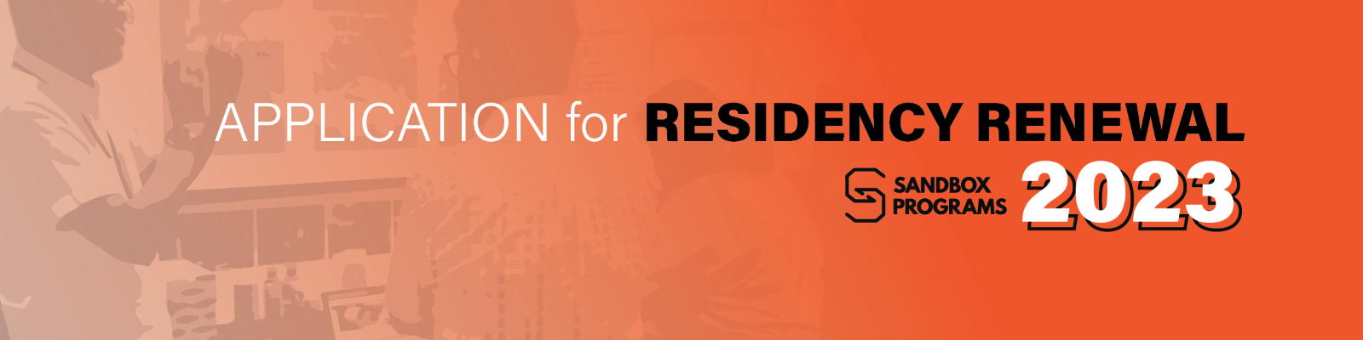

Areté Sandbox Residency - Renewal Application Form
For January-December 2023 cycle

Title of initial project (This is the title of the previous grant)

Working title of the project under the application for renewal

Project Proponents and Affiliations
- Lead Proponent must be a full-time faculty member of Ateneo de Manila University
- Curriculum Vitae of proponents should be attached to this application form
Lead Proponent (and affiliations)
Team Members (and affiliations)

In 1,500 words, what were you able to achieve during your Sandbox residency period?
What directions do you intend to pursue during this renewal period?
(To be submitted as a separate attachment in .pdf format)

What benefits would extending the Sandbox Residency bring?
(Please keep to within 500 words)

Describe the project's potential for further innovation and creative solutions, as well as with experimentation and play?
(Please keep to within 5-10 sentences)

Describe the project’s potential for further interdisciplinary?
(Please keep to within 3-5 sentences)

Describe the project's potential to further the merging of the sciences and the arts?
(Please keep to within 3-5 sentences)

Other sources of funding that accompany this project.
◻︎ YES ◻︎ NO
If yes, please indicate the funding bodies and the amount of funding applied for or received.

Relevant information that you wish to share in consideration of your application?

Names and Signatures of Applicants:
Date of Application:

